**Question 1**

1. Implement Naive Bayes Classifier on Iris Dataset  
2. Implement Decision Tree on Iris Dataset  
3. Find accuracy for different splitting points (training size = 0.5, 0.6, 0.7, 0.8, 0.9)  
4. Plot on a graph and compare

**Source Code**

**Naive Bayes Classifier**

import numpy as np

import matplotlib.pyplot as plt

from sklearn.datasets import load_iris

from sklearn.model_selection import train_test_split

from sklearn.naive_bayes import GaussianNB

from sklearn.metrics import accuracy_score, classification_report

from sklearn.decomposition import PCA

from matplotlib.colors import ListedColormap

def plot_decision_regions(X, y, classifier, resolution=0.02):

markers = ('s', 'x', 'o')

colors = ('red', 'blue', 'lightgreen')

cmap = ListedColormap(colors[:len(np.unique(y))])

x1_min, x1_max = X[:, 0].min() - 1, X[:, 0].max() + 1

x2_min, x2_max = X[:, 1].min() - 1, X[:, 1].max() + 1

xx1, xx2 = np.meshgrid(np.arange(x1_min, x1_max, resolution),

np.arange(x2_min, x2_max, resolution))

Z = classifier.predict(np.array([xx1.ravel(), xx2.ravel()]).T)

Z = Z.reshape(xx1.shape)

plt.contourf(xx1, xx2, Z, alpha=0.3, cmap=cmap)

for idx, cl in enumerate(np.unique(y)):

plt.scatter(x=X[y == cl, 0], y=X[y == cl, 1],

alpha=0.8, c=[cmap(idx)], marker=markers[idx],

label=f'Class {cl}')

def naive_bayes(t_size):

iris = load_iris()

X = iris.data # Features: sepal length, sepal width, petal length, petal width

y = iris.target # Target: species (0=setosa, 1=versicolor, 2=virginica)

feature_names = iris.feature_names

class_names = iris.target_names

X_train, X_test, y_train, y_test = train_test_split(X, y, train_size=t_size, random_state=42)

clf = GaussianNB()

clf.fit(X_train, y_train)

y_pred = clf.predict(X_test)

accuracy = accuracy_score(y_test, y_pred)

print(f"Accuracy: {accuracy:.2f}\n")

print("Classification Report:")

print(classification_report(y_test, y_pred, target_names=class_names))

pca = PCA(n_components=2)

X_train_pca = pca.fit_transform(X_train)

X_test_pca = pca.transform(X_test)

clf.fit(X_train_pca, y_train)

plt.figure(figsize=(8, 6))

plot_decision_regions(X_train_pca, y_train, classifier=clf)

plt.xlabel('Principal Component 1')

plt.ylabel('Principal Component 2')

plt.legend()

plt.title('Naive Bayes Decision Boundaries (PCA-transformed)')

plt.show()

return accuracy

if __name__ == '__main__':

acc = naive_bayes(0.7)

**Output**

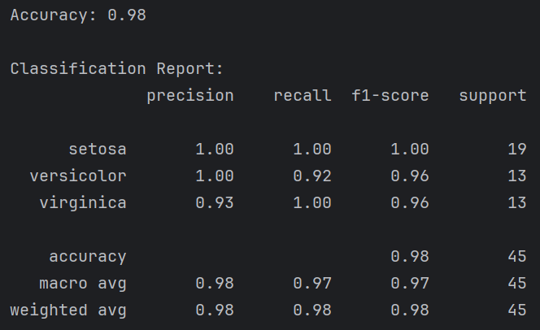*Terminal*

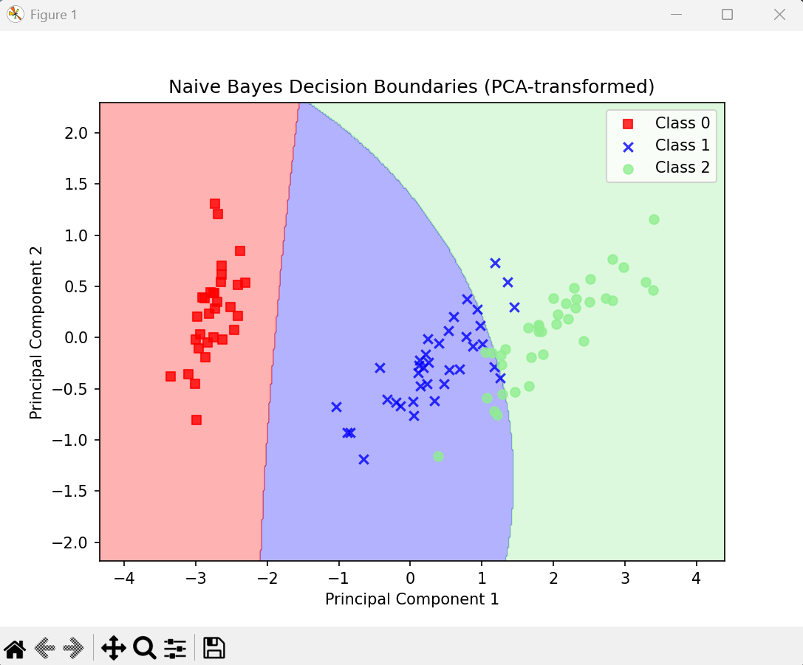*Visualization*

**Decision Tree**

from sklearn.datasets import load_iris

from sklearn.model_selection import train_test_split

from sklearn.tree import DecisionTreeClassifier, plot_tree

from sklearn.metrics import accuracy_score, classification_report

import matplotlib.pyplot as plt

def visualize_tree(clf, feature_names, class_names):

plt.figure(figsize=(10, 5))

plot_tree(

clf,

feature_names=feature_names,

class_names=class_names,

filled=True,

rounded=True,

fontsize=6,

)

plt.title("Decision Tree for Iris Species Classification", fontsize=16)

plt.show()

def dec_tree(train_size):

iris = load_iris()

X = iris.data # Features: sepal length, sepal width, petal length, petal width

y = iris.target # Target: species (0=setosa, 1=versicolor, 2=virginica)

feature_names = iris.feature_names

class_names = iris.target_names

X_train, X_test, y_train, y_test = train_test_split(X, y, test_size=1 - train_size, random_state=42)

clf = DecisionTreeClassifier(random_state=42)

clf.fit(X_train, y_train)

y_pred = clf.predict(X_test)

accuracy = accuracy_score(y_test, y_pred)

print(f"Accuracy: {accuracy:.2f}\n")

print("Classification Report:")

print(classification_report(y_test, y_pred, target_names=class_names))

visualize_tree(clf, feature_names, class_names)

return accuracy

if __name__ == '__main__':

acc = dec_tree(0.7)

**Output**

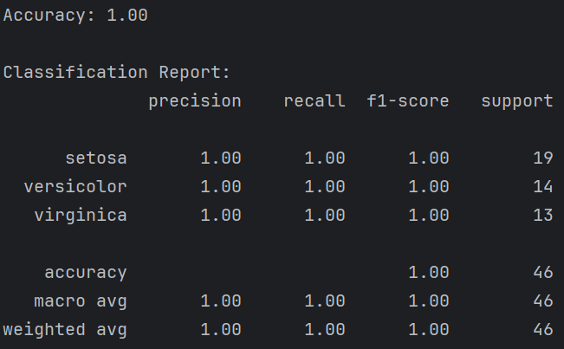*Terminal*

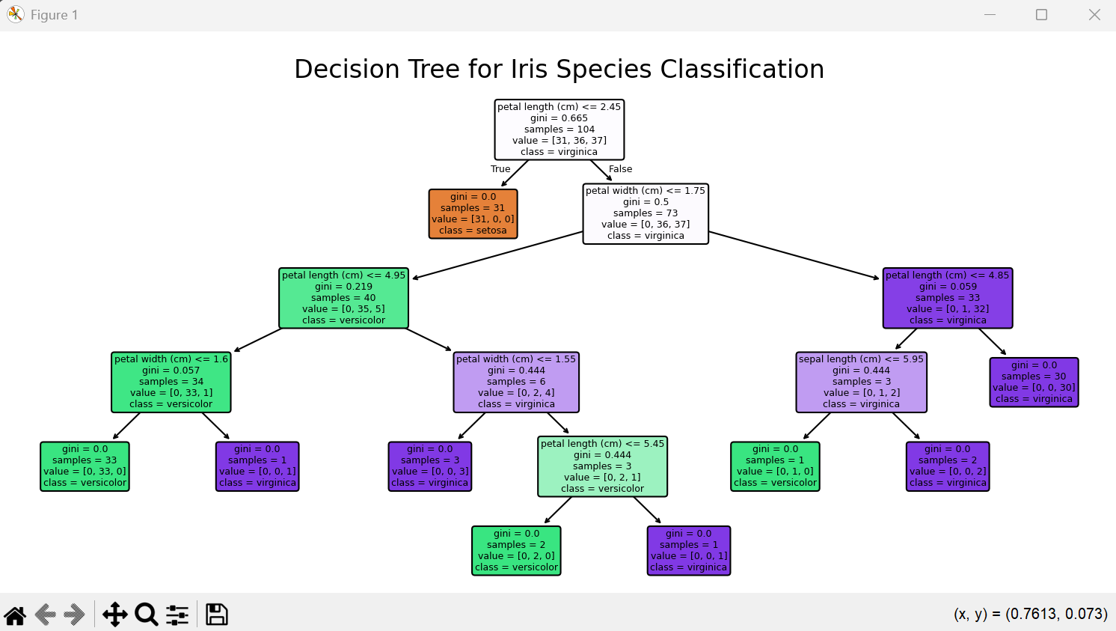*Visualization*

**Comparison**

from decision_tree_iris import dec_tree

from naive_bayes_classifier_iris import naive_bayes

import pandas as pd

import matplotlib.pyplot as plt

def comp():

accuracy_dec = {}

accuracy_nai = {}

for i in range(5, 10):

accuracy_dec.update({i/10:dec_tree(i/10)})

accuracy_nai.update({i/10:naive_bayes(i/10)})

df = pd.DataFrame({

'Key': accuracy_dec.keys(),

'Decision Tree': accuracy_dec.values(),

'Naive Bayes': accuracy_nai.values()

})

print (df)

plt.figure(figsize=(8, 4))

plt.plot(df['Key'], df['Decision Tree'], marker='o', label='Decision Tree', linewidth=2)

plt.plot(df['Key'], df['Naive Bayes'], marker='s', label='Naive Bayes', linewidth=2)

plt.title('Model Accuracy Comparison', fontsize=14)

plt.xlabel('Training Size', fontsize=12)

plt.ylabel('Accuracy', fontsize=12)

plt.xticks(df['Key'])

plt.ylim(0.85, 1.01)

plt.grid(True, linestyle='--', alpha=0.7)

plt.legend()

plt.tight_layout()

plt.show()

if __name__ == '__main__':

comp()

**Output**

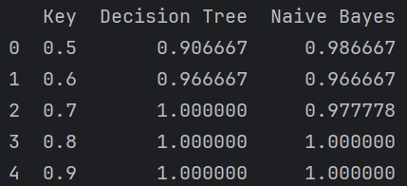*Terminal*

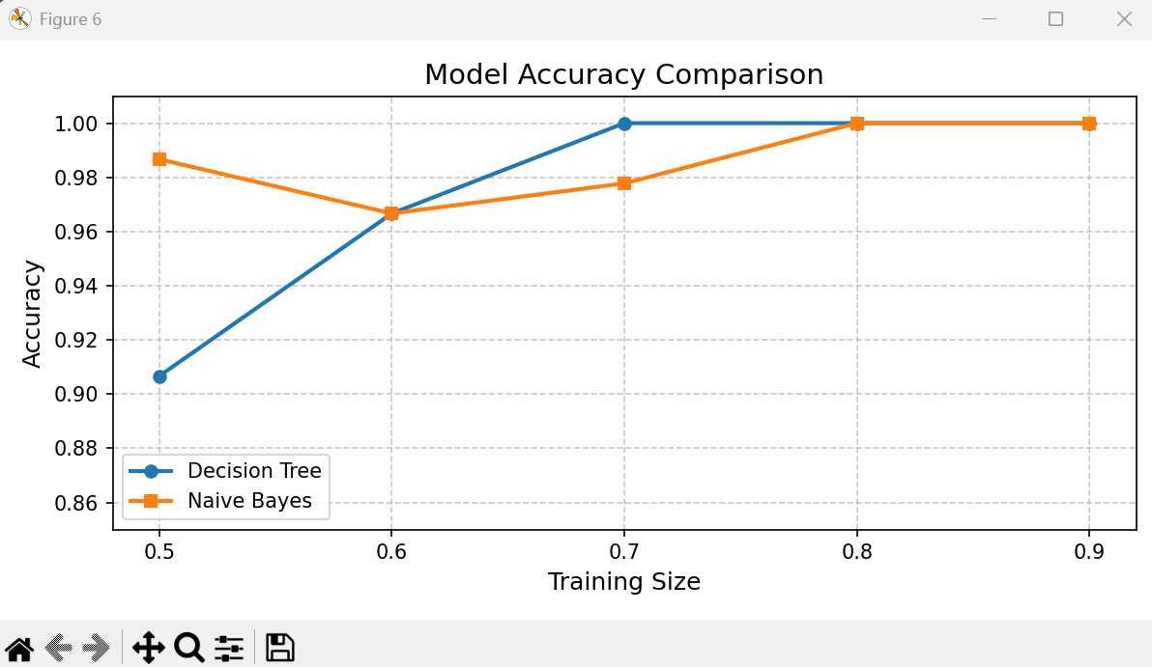*Visualization*